ADDITION UP TO NUMBER 10
KS1 – 2002 Paper
1.
KS1 – 2002 Paper
2.
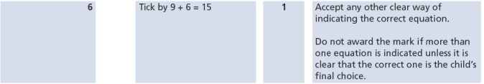

KS1 – 2004 Paper 1
3.
KS1 – 2007 Paper 1
4.
KS1 – 2009 Paper 1
5.
KS1 – 2016 Paper - Arithmetic
6.
7.
8.
KS1 – 2016 Paper - Arithmetic (Second)
9.
10.
KS1 – 2017 Paper – Arithmetic
11.
KS1 – 2018 Paper – Arithmetic
12.
KS1 – 2019 Paper – Arithmetic
13.
KS1 – 2022 Paper – Arithmetic
14.
15.

